-------------------------------------------------EXCELL ASSIGNMENT NO 09-----------------------------------------------

Q1). What are the different margins options and do we adjust the margins of the excel worksheet?

ANS: Normal, Wide, or Narrow are the different margin options in excel worksheet . we do have customer margins in excell as well to specify custom page margins, click Custom Margins and then—in the Top, Bottom, Left, and Right boxes—enter the margin sizes that you want. Yes we do adjust margins in Excel worksheet .

Q.2. Set a background for your table created.

ANS: 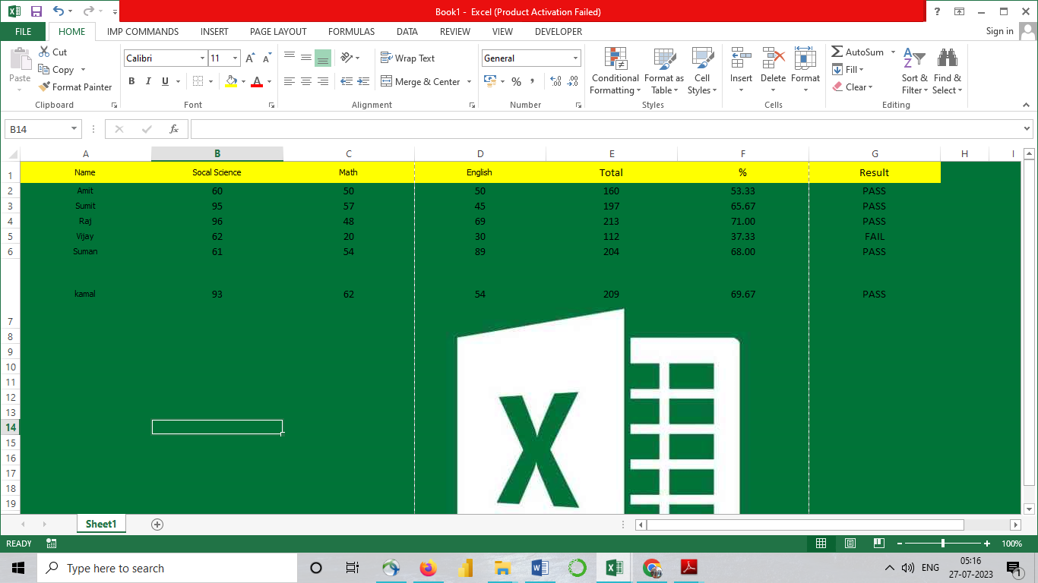

Q.3)What is freeze panes and why do we use freeze panes? Give examples.

ANS: The Excel Freeze Panes option allows you to lock your columns and/or rows so that when you scroll down or over to view the rest of your sheet, the column and/or row will remain on the screen

EXAMPLE: we want to freeze rows 1 and 2, so we'll select row 3. On the View tab, select the Freeze Panes command, then choose Freeze Panes from the drop-down menu. The rows will be frozen in place, as indicated by the gray line.

Q 4. What are the different features available within the Freeze Panes command?

ANS: Freeze panes : Freeze panes keeps the rows and columns visible while rest of the worksheet scrolls

Freeze Top Row : keeps the top row visible while you scroll through rest of the worksheet

Freeze first column : keeps the first column visible while you scroll through the rest of the worksheet .

Q.5)Explain what the different sheet options present in excel are and what they do?

### A: Insert: As soon as we click the Insert, the new blank worksheet will appear in the current workbook.

### B: Delete: Delete option is used to delete the sheets from the excel

### C: Rename: it is used to rename the sheet

### D: Move or Copy: this is used to move the sheet to a different location or create a duplicate by using copy

### E: View Code :We can launch VB (Visual Basic) Editor by going to any sheet tab, right-clicking ad choosing the option 'View Code

### F: Protect Sheet :If we protect any desired sheet within the workbook, Excel restricts users from editing or deleting the specific sheet.

### G: Tab Color :The sheet tabs can be colored with the desired color. We can change the default sheet tab's color by using this option

### H: Hide: we can hide the sheet from being it visible to any user

### I:unhide : It unhides the hidden sheet ,

### J: Select All Sheets :If we want to select all the workbook sheets at once, we can click on the 'Select All Sheets' option from the list. Once all the sheets are selected, we can perform some specific tasks on all the selected sheets at once.